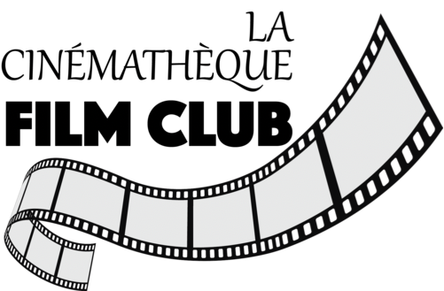

Fall Film series 2023
Belgian Cinema
Cleo from 5 to 7
(1961)
Directed by Agnes Varda

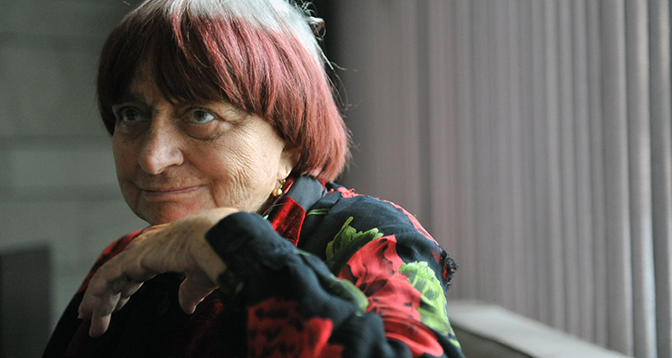

Varda, Agnès
Helen Carter

October 2002

Great Directors
Issue 22
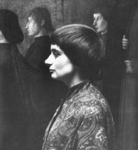
b. May 30, 1928, Ixelles, Belgium
d. March 29, 2019, Paris, France

Discovering Agnès Varda
My introduction to Agnès Varda is at the 2001 Sydney Film Festival. I go along expecting The Gleaners and I (Les Glaneurs et la Glaneuse, 2000) to be a drama feature and instead it is a documentary. I have no prior knowledge of this filmmaker. Somehow, ‘the grandmother of the French New Wave’ has escaped my attention. She is never mentioned in documentary classes. Her film doesn’t even warrant a picture in the festival program. Seems to be the story with her.
The Gleaners and I is a deliberately self-conscious documentary, taking the form of a cinematic poetic essay, where the filmmaker herself is very present in an unusual way. The literal translation of the title is “The Gleaners and the Gleaner” (feminine). Varda has intentionally and obviously placed herself intrinsically within the story. She narrates the film in her soothing French accent, and we learn that she is old, mindful of ageing, has recently discovered the mini DV camera, wonders about time and has a penchant for hypothesizing connections where there might (or might not) be one. “I’ll walk my small camera among the colored cabbages”, she says.
The film is ostensibly about people who ‘glean’ or collect, from the ground, the remnants of a harvest. “To bend down is not to beg” she says. And so the film sets about exploring past and present practices in gleaning, salvaging and picking. She interviews an eclectic range of people – ferals at the supermarket, gypsies in the field, middle-class anarchists, a winemaker who practices psychology and lawyers who, dressed in their archaic garb, articulate the legal parameters for gleaning under French law.
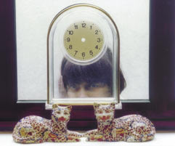
Varda herself collects a bunch of heart-shaped potatoes and leaves them on a shelf to rot. She compares herself to the decaying vegetables and introduces the themes of death, decay, and her own demise. She gathers images on her DV camera of her own hand, skin and greying hair and talks about the march of time. “I’m getting old, the end is near” she says. There is a clock with no hands, gleaned by Varda after it was overlooked by one of her subjects. We see her in a full-length mirror, holding her camera but she doesn’t look old. The film avoids becoming self-indulgent, managing to retain objectivity, probably in part due to her collaboration with other cinematographers and editors, though her own wisdom and decades of filmmaking should not be discounted.
Her love of paintings, both in their own right and as story telling devices, is explicit in this film, which is structured around well known paintings of gleaners by Van Gogh, Breton and Millet. In this film, she says, “I wanted to express my love for painting.” (3) The culmination of this idea is a copy of a Van Gogh which she has taken out of storage and shoots buffeted by wind, supported by two women. Her first visual inspiration though directly references film history: beautiful black and white footage of gleaners from the Russian film Earth (Dovzhenko, 1930).
Most delightful of all is the way this film incorporates Varda’s sense of fun and play. When the camera is accidentally left running, the lense cap bobbing in and out of frame, Varda opportunistically describes it as “the dance of the lense cap”. Varda gleans this footage that would otherwise be wasted. Equally revealing of her child-like playfulness are shots of her own hand inside a moving vehicle appearing to grasp trucks through the windscreen. Varda portrays herself as a collector of images and ‘right brain’ ideas: “There are many ways of being poor, having common sense, anger or humour.”
I decide to investigate Agnès Varda further, starting in the library of the Australian Film, Television and Radio School. I find out Varda is 74 years old and has been making films since the ’50s. Varda keeps good company alongside other respected septuagenarian filmmakers. Kubrick died the day after finishing Eyes Wide Shut (1999). Sascha Vierny shot his last feature for Greenaway at the age of 75. Perhaps, like good wine, cinematographers improve with age. Varda has preserved a youthfulness which is evidenced by her films and even her publicity pictures which show her as vibrant, dark haired, and young at heart.
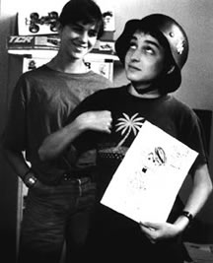
The library has Kung-Fu Master (1987) and several shorts. This time I am surprised to find that the Kung-Fu movie is not a documentary at all, but a feature length drama about an older woman (played by Varda’s friend and actress Jane Birkin) whose character falls in love with a young boy Julien, played by Mathieu Demy. One critic described it as “a subject tailor-made, one imagines, to frighten British distributors,” The film contains many of the themes seen in The Gleaners and I, asking: what does it mean to be old? Who can we love? What stories is cinema allowed to tell?
Although not visible in this film, Varda is very present in the story. The voice-over sounds like her and Birkin strongly resembles Varda. In fact, I discover, the boy is played by Varda’s own son, and his sisters by Birkin’s daughters, Charlotte Gainsborough and Lou Doillon. This suggests a whole new layer of meaning and pleasure in viewing the film. Ruth Hottell suggests “Varda’s cinema is one of subjective inclusion: she includes herself, her friends, and her family directly and indirectly in her films.” The playful prelude has the teenage Julien acting out a game character, in jerky movements with appropriate electronic sounds. The scene is played out in front of a shop window and under cranked to add to its comic style.
L’Opéra-Mouffe (A pregnant woman’s notebook) (1958) was made while Varda was pregnant with her first child Rosalie. It is a wonderfully feminine film about pregnancy and life on rue Mouffetard in Paris. A woman’s swollen belly is juxtaposed with a huge pumpkin, which is quartered to reveal it bulging with seeds. A montage in a fruit and vegetable market, intercut with faces of old people shopping, is reminiscent of The Gleaners and I. L’Opéra-Mouffe is segmented by chapters with hand-written titles which is also ‘very Varda’. In many ways she has come the full circle with her most recent film.
Uncle Yanco (1967) appears comparatively conventional for Varda. It is a documentary that researches her family history. She visits her bohemian Uncle Yanco, who lives amongst artists on a pier in San Francisco, and of course takes her camera with her. Varda makes no effort to hide the fact that she is making a film and once again includes herself in the story. The artists sit down to eat a huge meal, Varda and Yanco presiding at the head of the table. Part way through she whistles to the camera and gestures, presumably to one of the visitors, to turn it off. This is indicative of her code of honesty, whereby she is explicitly implicated in the filmmaking process and storytelling. Ironically this provides the viewer with a reading of greater objectivity. Another scene has Yanko yelling down to Varda, “Agnès, I love you dearly, but let me take a nap!” The film culminates with a surreal sequence of clapperboards and artists wearing “Viva Varda” badges, while Varda voices her thanks to the crew for their contribution (a device used two years later by Altman in M.A.S.H.). She readily admits, “I am always very precisely implicated in my films, not through narcissism but through honesty in my approach.” (7) Varda’s honesty is her strength and originality, and this benefits the audience with an unexpected perspective. Varda avoids judging her characters, rather trying to find connections between them, their environment and her own life. And hence her place within the film.
T’as de beaux escaliers, tu sais (1986) appears to be a documentary for a museum of cinema and refers to the great history of films by Welles, Kurosawa, Truffaut, Godard and Vidor, to name a few (despite weeks of research, I cannot find any information to verify this). In it, the director re-enacts playfully Potemkin’s Odessa steps sequence and Truffaut’s anarchists on the steps of the Paris Museum. The film is a loving homage to film culture and includes common elements of Varda’s films. All of her films reference the film frame through the use of curtains, shooting through shop windows and archways and usually including other films within her film. The Gleaners and I includes short clips of moving image pioneer Etienne-Jules Marey; L’Opéra-Mouffe closes with a roller door eclipsing the frame. Uncle Yanco includes a scene where neice and uncle act out their reunion; the scene becomes surreal when it is repeated (cheekily) in several takes, incorporating the clapperboard and editor’s china graph sync marks.
On leaving the library, I find a box of old Cinema Papers magazines being given away. I blindly reach in and glean a couple of issues; one has an interview with Varda from her 1983 visit to Australia. In it, she laments “the word documentary has been spoilt. You say documentary and people say what a bore. We should have middle words.” (8) At this point I am unaware of how difficult it will prove to be to find anything written about Varda in English. On the internet I find only the same interviews reconstituted into different websites, with very little biographical information.
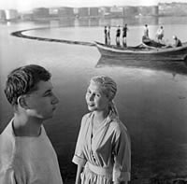
Agnès Varda was born in Ixelles, Belgium on May 30, 1928, and grew up on a port in the Sète district of Provence. She studied art history at the Ecole du Louvre then worked as official photographer for the Théâtre National Populaire. Her colleagues of the Left Bank, Chris Marker and Alain Resnais, encouraged her to direct her first feature, La Pointe Courte (1954), ahead of the French New Wave. This was despite her having no previous film making experience. She had only ever seen 20 films prior to this. In 1962 she married celebrated French filmmaker Jacques Demy, most famous for his film Lola (1960), and they had a son Mathieu (b. 1972) who has acted in many of Varda’s films since. Jacques died in 1990, the same year that Varda made her tribute to his early life: Jacquot de Nantes. Jacques apparently loved the film and played himself as an adult reminiscing. Varda also has a daughter, Rosalie, but I can glean no more about her and she does not appear in any filmographies of Varda. In 1977 the director founded her own production company, Cine-Tamaris, which she says allows her the freedom to shoot and edit in tandem. She has shot films in Iran, France, the US and Cuba. Varda has lived and worked on the rue Daguerre for more than 40 years. From this habitat sprang her film Daguerrèotypes (1975), based on the inhabitants of the street.
Unlike her contemporaries who wrote for the Cahiers du Cinéma, Varda resists intellectualising about film. She has however developed her own notion of cinécriture, which she describes as the process of ciné-writing, but in the most broadest of senses: editing style, voice-over commentary, choosing the place, the season, the crew and the light. In 1994 she wrote a book about her life and work, Varda par Agnès, which was published by Cine-Tamaris and Cahiers du Cinéma Although often connected to the French New Wave directors, her path remains different in that she directs documentary as well as drama, shorts and feature length films.
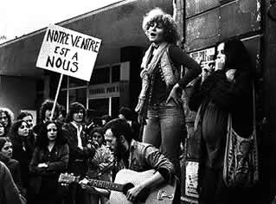
Most articles about Varda center around arguments for or against her work as a feminist. She exists as part of a long history of French-language female filmmakers including Germaine Dulac, Marguerite Duras, Chantal Akerman and Alice Guy (who is distinguished as the first woman film director). Varda is dismissed by critic Claire Johnston as “reactionary and certainly not feminist”, yet is considered by most to be an exemplar of feminist filmmaking for her consistent use of female protagonists and crafting of a female cinematic voice. When asked if she saw herself as a feminist, she replied “I wasn’t always very clear about discrimination and it’s not exactly my image.” In 1967 Chris Marker collaborated with some of France’s best known directors (Godard, Resnais, Lelouch etc.) on an anti-war documentary titled Loin du Viet-Nam. Agnès Varda also contributed but reviewers rarely gave her a mention. According to Sight and Sound writer Jill Forbes, “the silence is so systematic that Varda’s exclusion must be related to the fact that she is a woman.” She is never included amongst discussions about La Nouvelle Vague. Whether or not her films can be regarded as feminist, they are certainly about women, contain socio-political, philosophical and current themes without ever losing a sense of fun or the art of entertaining an audience.
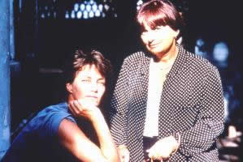
In 1987 Varda made her Diptych dedicated to Jane Birkin I and II, which comprised her two films Jane B. Par Agnès V. (97 mins) and Kung-Fu Master (Le Petit Amour, 78 mins). I am not the only one to confuse the second film for a documentary and so it has now been released (on video only) with its French title. The first film is a character sketch of Birkin, an actuality, while the second film is fictional and also includes stars Birkin. The fiction film emerged during the shooting of the documentary when Birkin gave Varda a 10-page character sketch which Varda then wrote into a feature length drama. Kung-Fu Master also stars both Birkin’s and Varda’s children, adding to the complex riddle of truth and fiction. These two films reflect upon each other and ask questions about representation of women on the screen, fiction and reality. Each is a film in its own right, but together they say much more. Unfortunately the documentary has not been picked up by a distributor and the fictional film has only been released on video so audiences are unlikely to have the full impact of this unusual duo.
Jacquot de Nantes is a loving souvenir of her husband, the filmmaker Jacques Demy. It is sometimes described as documentary, but the film mostly comprises recreations of Jacques’ childhood memoirs. It was filmed in Nantes which adds veracity to its look. The film features clips of his first film adventures, including lovely 9.5mm hand drawn images. Demy himself has a presence, speaking directly to camera (Varda) about his life. The camera pans tenderly along his skin, showing every pore, hair and blemish. Poignantly recalling similar shots in the Gleaners and I, the two films form another duo, together representing a chapter in Varda’s own life. Jacquot du Nantes begins with Varda’s now very familiar voice reminiscing about her lover. It provides an unusual intimacy which connects the viewer to them. He lies on a long sandy beach near the ocean of collective unconscious, sifting yellow grains through his fingers. She honours Jacques Demy by placing him within the infinite sands of humanity.
Most articles cite Sans Toit Ni Loi (Vagabond, 1985) as Varda’s most successful and best-known feature film but I am unable to source it and instead settle for her second (fictional) feature Cléo de 5 à 7 (1961), a beautifully crafted story about a pop singer who has two hours to wait for results from a cancer test. The film is actually 90 minutes long but feels true to the allotted narrative time frame. It opens with a scene in colour of an old woman reading Cléo’s tarot cards: her life is clearly laid out. The film then reverts to black and white for its duration. Cléo de 5 à 7 has many (documented) resonances with L’Opéra-Mouffe and includes scenes of Cléo wandering the Paris streets backgrounded by people going about their everyday lives. Varda typically displays a “tendency to inflect narrative with reality”. Varda wrote her own haunting lyrics for Cléo’s songs and casts her friends Godard and Legrand in minor roles. The film is marked by chapters which indicate who the scene is about and emphasise the progression of time.
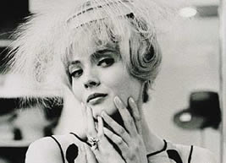
The film is rich in Jungian symbols: Cléo shops for a hat which she later gives to her friend and then removes her pop-singer’s wig to reveal her naturally beautiful, ordinary self, indicating she is now ready to play a different role. Stairs (interior and exterior) feature in all of Varda’s films and here suggest that Varda is interested in the collective psyche, the society, which is represented by her characters but should be taken out onto the streets and referenced to contemporary culture. Cléo has a clock with a monkey on it, a sign that time is the monkey on this woman’s back. The streets are papered with movie posters and there is the typical film-within-a-film which serves as a catalyst to pick Cléo up out of her self-obsession and move her forward. The film echoes Varda’s general discussions around ageing: “People are obsessed with cancer and heart trouble. My disease is work, phone calls and appointments.” According to Varda, “at that time, the collective fear was of cancer, just as the nuclear bomb or war is now.
Agnès Varda has always been ahead of her time – in filmmaking technique and style and also in political commentary. Just as The Gleaners and I is a contemporary look at capitalism and urban life and utilizes the latest in digital cinematography, Kung-Fu Master sits comfortably alongside other dramas of the ’80s including those of Loach, Bergman and Greenaway. Uncle Yanco reflects the bohemian, drug-taking, moral ambivalence of the late ’60s and Cléo de 5 à 7 displays a French obsession with cars, fashion and identity. Agnès Varda is grandmother to the world community of filmmakers. At 74 she has a good perspective on a life which has given her breadth of filmmaking experience, it is hardly surprising she keeps going. “I think communication is difficult but essential and not just in love, but in work, in the relationship with one’s children, in one’s general attitude” There is some accepted wisdom which says, people only ever write the same book or film script over, but Varda has produced at least one unique gem for each of her five decades as writer, director and cinematographer. Her body of work cannot be described by genre, let alone fiction or reality. One imagines The Gleaners and I may well be her last film offering but as she has shown herself to be still so full of curiosity and zest for life, she may well have more to say.
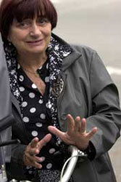

Filmography
Pointe Courte (1954) 89 mins
O Saisons, O Châteaux (1957) 22 mins
L’Opéra-Mouffe (1958) 17 mins
Côté de la côte (1958) 24 mins
Cléo de 5 à 7 (Cléo from 5 to 7) (1961) 90 mins
Salut les Cubains (1963) 30 mins
Le Bonheur (Happiness) (1964) 82 mins
Enfants du Musée (1964) 7 mins
La Rose (1966) 20 mins
Créatures (1966) 105 mins
Uncle Yanco (1967) 22 mins
Loin du Vietnam (in collaboration with other directors, 1967)
Panthers (1968) 28 mins
Love (…and Lies) (1969) 110 mins
Nuasicaa (1970) 90 mins [Vanished]
Daguerréotypes (documentary, 1975) 80 mins
Réponse de femmes (1975) 8 mins
Plaisir d’amour en Iran (1976) 6 mins
Une chante, l’autre pas (One Sings, the Other Doesn’t) (1976) 120 mins
Femmes Bulles (video, 1977) 58 mins, video
Murs (Mural Murals) (documentary, 1980) 81 mins
Documenteur (An Emotion Picture) (1981) 63 mins
Ulysse (1982) 22 mins
Minute pour une image (1982) 170 two-minute spots for television
Dites Caryatides (1984) 13 mins
Cuis., s. de b… (1984) 27 mins
Toit ni loi (Vagabond) (1985) 105 mins
Winner of Grand Priz at Venice Film Festival
De beaux escaliers, tu sais… (1986) 3 mins
B. par Agnès V. (1987) 97 mins
Kung-fu Master (Le Petit Amour) (1987) 78 mins
Jacquot de Nantes (Jacquot) (1990) 118 mins
Demoiselles ont eu 25 ans (The Young Girls Turned 25) (documentary, 1992) 63 mins
Cent et une nuits (One Hundred and One Nights) (1994) 100 mins, made for the centennial of cinema
L’Univers de Jacques Demy (The World of Jacques Demy) (documentary, 1995) 90 mins
Les Glaneurs et la glaneuse (The Gleaners and I) (documentary, 2000) 82 mins
Winner of Best Documentary of 2001:
-National Society of Film Critics
-New York Film Critics Circle
-Chicago International Film Festival
-Los Angeles Film Critics Association
-New York Film Critics Online
Le Lion volatil (2003) 12 mins
Cinevardaphoto (2004)
Quelques veuves de Noirmoutier (2006)
Les Plages de Agnès (The Beaches of Agnès (2008)
POV (Tv Series, 1 episode, 2010)
Agnes Varda: From Here to There (Tv Series, 2011)
Visages, villages (Faces, Places, 2017) co-directed w/ JR

