50 Years of Italian Cinema
South Orange Public Library
Winter 2016-2017

Vittorio De Sica
1901-1974

Shoeshine
1946
Movie Review: Shoeshine
Thomas M. Pryor • August 27, 1947
Article sourced from The New York Times: http://www.nytimes.com/movie/review?res=EE05E7DF173DE270BC4F51DFBE66838C659EDE

The plight of Italy's homeless, hungry children in the days immediately after the downfall of fascism is recounted in harrowing pictorial terms in Shoeshine. This Italian-made drama, which had its premiere here last night at the Avenue Playhouse under the sponsorship of the New York Newspaper Guild, is not a pretty picture to contemplate nor is it by any means a well-made picture.
But Shoeshine mirrors the anguished soul of a starving, disorganized, and demoralized nation with such uncompromising realism that the roughness of its composition is overshadowed by its driving, emotional force. Quick transition of scenes tends to disturb the continuity, but in other respects the direction of Vittorio De Sica reveals keen and sympathetic understanding of the nature of embittered, frustrated youth.
Fascism's bequest to the children of Italy was a bitter cup of gall, and Shoeshine is an unrelenting study of the despair and corruption that seared the hearts and minds of so large a part of Italy's future manhood. Mr. De Sica got the inspiration for this film from the hordes of sickly, undernourished, and ill-clothed street urchins who followed American troops into Naples, Rome, and other cities with their shoeshine boxes, badgering the GI's with their cries of "Shoosha, Joe." Some of these pathetic youngsters became pawns in the hands of unscrupulous black marketeers and, like Giuseppe and Pasquale, were tossed into jail to languish and lose whatever vestige of goodness remained in them while inefficient police authorities halfheartedly sought the real criminals.
It is against unjust incarceration and the inhuman handling of such unfortunate victims of war that Shoeshine cries out so eloquently. For where compassion should have been exercised, the big stick of authority was applied instead. The reform school in which Giuseppe and Pasquale are confined is a fine breeding place for criminals, for, in addition to suffering shocking physical discomforts, the boys are supervised by corrupt guards who steal from their meager food packages and are always open to bribes.
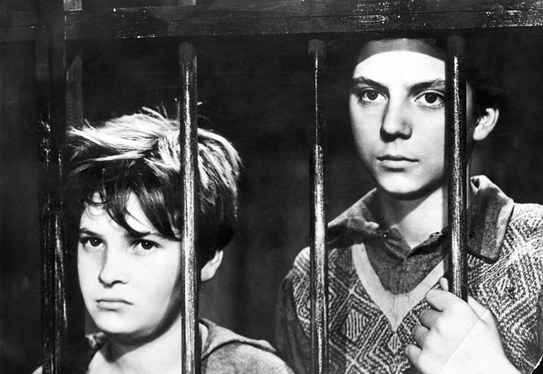
The complete hopelessness with which the film regards the future of these youths is cruelly dramatized by the brutal, though accidental, death Giuseppe meets at the hands of his friend, Pasquale, after a prison break. The only heartening thing about Shoeshine is the knowledge that this film was instrumental in bringing about reforms in the treatment of juvenile delinquents in Italian institutions, for the picture offers no solution to the problem it presents.
Director De Sica, working with boys who never before had faced a movie camera, much less acted, has done a masterful job in coaching his cast. Rinaldo Smordoni as Giuseppe and Franco Interlenghi as Pasquale are so genuine one never for a moment thinks of them as actors, and, indeed, they are not, for theirs are naturalistic performances devoid of any histrionic techniques. Moreover, Mr. De Sica has peppered the picture with the vulgar mannerisms typical of the street urchins, and the English title translations by Herman G. Weinberg preserve the earthy tone of their talk. Shoeshine is not an entertainment; rather, it is a brilliantly executed social document.

SHOESHINE (MOVIE)
Directed by Vittorio De Sica; written (in Italian, with English subtitles) by Sergio Amidei, Adolfo Franci, C. G. Viola, and Cesare Zavattini, based on a story by Mr. Zavattini; cinematographer, Anchise Brizzi; music by Alessandro Cicognini; produced by Paolo W. Tamburella; released by Lopert Films. Black and white. Running time: 93 minutes.

Selected Filmography (as director)

- The Voyage (1974)
- A Brief Vacation (1973)
- Lo chiameremo Andrea (1972)
- I cavalieri di Malta (1971) tv movie documentary
- Dal referendum alla costituzione: Il 2 giuno (1971) tv movie documentary
- The Garden of the Finzi-Cotinis (1970)
- Sunflower (1970)
- A Place for Lovers (1968)
- Woman Times Seven (1967)
- After the Fox (1966)
- Un monde nouveau (1966)
- Marriage Italian Style (1964)
- Yesterday, Today and Tomorrow (1963)
- The Boom (1963)
- The Condemned of Altona (1962)
- The Last Judgment (1961)
- Two Women (1960)
- The Roof (1956)
- The Gold of Naples (1954)
- Indiscretion of an American Wife (1953)
- Umberto D. (1952)
- Miracle in Milan (1951)
- Bicycle Thieves (1948)
- Shoeshine (1946)
- La porta del cielo (1945)
- The Children are Watching Us (1944)
- Un garibaldino al convento (1942)
- Doctor, Beware (1941)
- Maddalena… zero in condotta (1940)
- Rose scarlatte (1940)

50 Years of Italian Cinema
South Orange Public Library
Winter 2016-2017

Federico Fellini
1920-1993

Nights of Cabiria
1957
Great Movie: Nights of Cabiria
Roger Ebert • August 16, 1998
Article sourced from RogerEbert.com: http://www.rogerebert.com/reviews/great-movie-nights-of-cabiria-1957

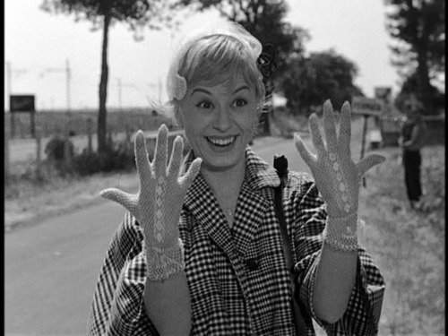
Cabiria's eyebrows are straight, black horizontal lines, sketched above her eyes like a cartoon character's. Her shrug, her walk, her way of making a face, all suggest a performance. Of course a prostitute is always acting in one way or another, but Cabiria seems to have a character in mind--perhaps Chaplin's Little Tramp, with a touch of Lucille Ball, who must have been on Italian TV in the 1950s. It's as if Cabiria thinks she can waltz untouched through the horrors of her world, if she shields herself with a comic persona.
Or perhaps this actually is Cabiria and not a performance: Perhaps she is a waiflike innocent, a saint among the sinners. It is one of the pleasures of Giulietta Masina's performance that the guard never comes down. As artificial as Cabiria's behavior sometimes seems, it always seems her own, and this little woman carries herself proudly through the gutters of Rome.
“Nights of Cabiria,” directed by Masina's husband, Federico Fellini, in 1957, won her the best actress award at Cannes, and the film won the Oscar for best foreign picture--his second in a row, after “La Strada” in 1956 (he also won for “8 1/2” in 1963 and “Amarcord” in 1974). Strange, then, that it is one of Fellini's least-known works--so unfamiliar that he was able to recycle a lot of the same underlying material in “La Dolce Vita” only three years later.
Now the movie has been re-released in a restored 35-mm. print, with retranslated, bolder subtitles giving a better idea of the dialogue by Pier Paolo Pasolini. There is also a 7 1/2-minute scene that was suppressed in earlier versions of the film.
Seeing it in its new glory, with a score by Fellini's beloved composer Nina Rota, “Nights of Cabiria” plays like a plucky collaboration on an adult theme between Fellini and Chaplin. Masina deliberately based her Cabiria on the Little Tramp, I think--most obviously with some business with an umbrella, and a struggle with the curtains in a nightclub. But while Chaplin's character inhabited a world of stock villains and happy endings, Cabiria survives at the low end of Rome's prostitution trade. When she's picked up by a famous actor and he asks her if she works the Via Veneto, the center of Rome's glitz, she replies matter-of-factly that, no, she prefers the Archeological Passage, because she can commute there on the subway.
Cabiria is a working girl. Not a sentimentalized one, as in “Sweet Charity,” the Broadway musical and movie based on this story, but a tough cookie who climbs into truck cabs, gets in fights and hides in the bushes during police raids. She's proud to own her own house--a tiny shack in an industrial wasteland--and she dreams of sooner or later finding true romance, but her taste in men is dangerous, it's so trusting; the movie opens with her current lover and pimp stealing her purse and shoving her into the river to drown.
By the nature of their work prostitutes can find themselves almost anywhere in a city, in almost any circle, on a given night. She's admitted to the nightclub, for example, under the sponsorship of the movie star (Alberto Lazzari). He picks her up after a fight with his fiancee, takes her to his palatial villa, and then hides her in the bathroom when the fiancee turns up unexpectedly (Cabiria spends the night with his dog). Later, seeking some kind of redemption, she joins another girl and a pimp on a visit to a reputed appearance by the Virgin Mary. And in the scene cut from the movie, she accompanies a good samaritan as he visits the homeless with food and gifts (she is shocked to see a once-beautiful hooker crawl from a hole in the ground).
All of these scenes are echoed in one way or another in “La Dolce Vita,” which sees some of the same terrain through the eyes of a gossip columnist (Marcello Mastroianni) instead of a prostitute. In both films, a hooker peeps through a door as a would-be client makes love with his mistress. Both have nightclub scenes opening with exotic ethnic dancers. Both have a bogus appearance by the Virgin. Both have a musical sequence set in an outdoor nightclub. And both have, as almost all Fellini movies have, a buxom slattern, a stone house by the sea, a procession and a scaffold seen outlined against the dawn. These must be personal touchstones of his imagination.
Fellini was a poet of words and music. He never recorded the dialogue at the time he shot his films. Like most Italian directors, he dubbed the words in later. On his sets, he played music during almost every scene, and you can sense in most Fellini movies a certain sway in the way the characters walk: Even the background extras seem to be hearing the same rhythm. Cabiria hears it, but often walks in counterpoint, as if to her own melody. She is a stubborn sentimentalist who cannot believe the man she loved--the man she would do anything for--would try to drown her for 40,000 lira. (“They'd do it for 5,000,” her neighbor assures her.)
She is a woman seeking redemption, a woman who works as a sinner but seeks inner spirituality. One night she happens into a performance by a hypnotist, is called onstage, and in the film's most extraordinary sequence is placed in a trance (half vaudeville, half enchanted fantasy) in which she reveals her trust and sweetness. She also informs the rude audience that she has a house and a bank account.
A man named Oscar (Francois Perier) sees her on the stage and begins to court her with flowers and quiet sincerity. He is touched by her innocence and goodness, he says, and she believes him. At last she has found a man she can trust, to spend her whole life with. She is filled with joy, even as her friends (and we in the audience) despair of her naivete.
Fellini's roots as a filmmaker are in the postwar Italian Neorealist movement (he worked for Rossellini on “Open City” in 1945), and his early films have a grittiness that is gradually replaced by the dazzling phantasms of the later ones. “Nights of Cabiria” is transitional; it points toward the visual freedom of “La Dolce Vita” while still remaining attentive to the real world of postwar Rome. The scene involving the good samaritan provides a framework to show people living in city caves and under bridges, but even more touching is the scene where Cabiria turns over the keys of her house to the large and desperately poor family that has purchased it.
These scenes provide an anchor, an undertow, that lends a context to the lighter scenes, like the one where she is mocked by two Via Veneto prostitutes who are more elegant (and much taller) than she is. Or the scene where she drives away in the actor's big American car while flaunting her new client to her rival prostitutes (again, a scene Fellini would recycle in “La Dolce Vita”). In all of those scenes she remains in defiant character, and then we sense a certain softening toward the end. As she allows herself to believe that her future lies with Oscar, her eyebrows subtly soften their bold horizontal slashes, and begin to curve above eyes and a face that seem more vulnerable. It's all in preparation for the film's unforgettable last shot, in which we see Cabiria's face in all its indomitable resolve.
Of all his characters, Fellini once said, Cabiria was the only one he was still worried about. In 1992, when Fellini was given an honorary career Oscar, he looked down from the podium to Masina sitting in the front row and told her not to cry. The camera cut to her face, showing her smiling bravely through her tears, and there was Cabiria.

Selected Filmography (as director)

- The Voice of the Moon (1990)
- Intervista (1987)
- Ginger and Fred (1986)
- And the Ship Sails On (1983)
- City of Women (1980)
- Orchestral Rehearsal (1978)
- Amarcord (1973)
- Roma (1972)
- The Clowns (1970) tv movie documentary
- Fellini Satyricon (1969)
- Juliet of the Spirits (1965)
- 8 ½ (1963)
- La Dolce Vita (1960)
- Nights of Cabiria (1957)
- Il Bidone (1955)
- La Strada (1954)
- I Vitelloni (1953)
- The White Sheik (1952)
- Variety Lights (1950)

50 Years of Italian Cinema
South Orange Public Library
Winter 2016-2017

Michelangelo Antonioni
1912-2007

La Notte
1961
La Notte
Gwendolyn Audrey Foster • February 2015
Article sourced from Senses of Cinema: http://sensesofcinema.com/2015/cteq/la-notte/

One question I am often asked is why the women in my films are more lucid than the men. I was raised among women: my mother, my aunt, and lots of cousins. Then I got married, and my wife had five sisters. I have always lived among women; I know them very well . . . Speaking for myself, I find that the feminine sensibility is a far more precise filter than any other to express what I have to say. In the realm of emotions, man is nearly always unable to feel reality as it exists. Having a tendency to dominate woman, he is tempted to hide some of her aspects from himself and see her as he wants her to be. There is nothing absolute in this area, but it seems to me that is at the heart of it.
- Michelangelo Antonioni

In reviewing the critical reception of La notte (1961), it strikes me that many observers seem to almost completely miss the fact that the film is, in part, a feminist critique of capitalist society, which centres around women, consumption, and the failure of our ecosystem, and not just the director’s trademark alienation and ennui.
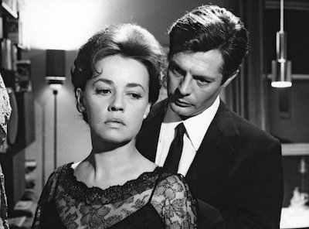
Conventional plot summaries of the film routinely insist that La notte centres around a male author, Giovanni Pontano (Marcello Mastroianni), his uncertain career, and his failing relationship with his wife, Lidia (Jeanne Moreau), as well as his flirtations with beautiful socialite Valentina Gherardini (Monica Vitti).
I would argue, rather, that women are both the centre of the film and the mirrors upon which Antonioni reflects his dark perceptions and stark conclusions about the human condition. At a launch party for his latest novel, those who celebrate Giovanni’s newest book spend precious little time actually reading, opting instead to party all night, while simultaneously remaining oblivious to their own mortality.
As in most of his films, Antonioni’s wealthy protagonists in La notte live in a hell of their own making. So thoroughly alienated are they from one another (and from the environment) that they experience the rain from the sky (in the pool sequence) as a sublime rapture from above, giggling like schoolchildren, briefly lifted out of their stupor for a moment’s play with the actual elements.
The tragedy of Antonioni’s characters is not simply a matter of bored bourgeois ennui; these people are disconnected from the feminine, from the earth, and from life itself. Perhaps no critic got it more wrong than Pauline Kael in her infamous essay “The Come-Dressed-As-the-Sick-Soul-of-Europe Parties: La Notte, Last Year at Marienbad, La Dolce Vita,” in which Kael attacked the film, demanding less ambiguity:
La notte is supposed to be a study in the failure of communication, but what new perceptions of this problem do we get by watching people on the screen who can’t communicate if we are never given any insight into what they could have to say if they could talk to each other?

On the contrary, Antonioni gives us nothing but insight into the various relationships, and thus I find her dismissal baffling. More recently, critic Christopher Sharrett takes a far more perceptive feminist eco-critical approach to key Antonioni films such as Il deserto rosso (Red Desert, 1964) and L’eclisse (1961), noting of L’eclisse that “the failure of people to connect is rooted less in vague existential dread than in concrete social realities”. For me, it is those specific social realities that are most vividly explored and exposed in La notte.
Antonioni’s key, early films are best understood from the point of view of a feminist director – keeping in mind Antonioni’s own philosophy, as noted above, “the feminine sensibility is a far more precise filter than any other to express what I have to say.” Sharrett’s perceptive comments on Red Desert also apply to La notte. He notes that Red Desert is:
explicit in its insistence that the sensitive individual (who must be, in the director’s view, axiomatically female, with little possibility for the male partaking of authentically human sensibility) cannot enjoy happiness in this end-product of patriarchal capitalist rule. A pervasive theme in Antonioni’s work is the concept ‘Eros is sick,’ meaning that the erotic, the drive for life, is sickened and doomed by the death drive in a society operating under the assumptions of capitalism and repression . . .

Filmed on location in Milan, the opening credits shot is a stunner. The camera glides in a long track down the exterior of a glass-facade building, suggesting a descent into hell. Images of nature are fleeting in La notte – a few scrub trees in a desolate urban environment; the sky violated by amateur rocketry competitions; unfinished buildings everywhere – depicting Milan as an unnatural colonization of the feminine earth.
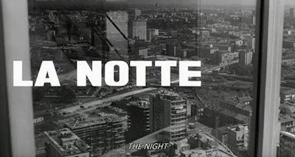
Humans in La Notte shuffle along resembling zombie-like “sleepwalkers.” Specific allusions to sleepwalking abound, the most direct being a reference to Hermann Broch’s classic 1932 novel, which Giovanni picks up at the party with an air of surprise, wondering aloud, “Who is reading The Sleepwalkers?” Broch’s own obsession with the death of values and the decay of humanity mirrors La notte’s central preoccupation with mortality as it relates to the value of love and art (as Eros).
Mortality is omnipresent in the opening sequence in a hospital room, where Giovanni and Lidia visit their dying friend, an author named Tommaso (Bernhard Wicki). Tommaso wonders aloud if any of his life’s work is of value, and ironically Giovanni himself is battling the same sorts of questions, the central post-war preoccupations of modernism; self-doubt, alienation, and existentialism. Giovanni’s self absorption precludes him from a loving relationship with his wife, Lidia, who patiently waits for him to grow up during the entire length of the film.
Antonioni crafts our perspective so that we see Giovanni primarily through Lidia’s point of view. Though he is unfaithful, selfish, and childish, Lidia still loves Giovanni, but she is keenly aware that their marriage is barely alive. Lidia observes Giovanni trying to woo the stunning young Vitti, but instead of protesting, she seems to almost push her husband into Valentina’s arms through her powerful gaze.
Though Moreau is said to have disliked the role of Lidia, it is one of her finest performances and most of her power is established through her active gaze. In a strong and memorable sequence, Lidia wanders the streets looking at life going on around her, watching the activities of workmen and women of all types. Lidia seems keenly aware that life is going on around her, but in many ways without her, as she feels the pain of her own mortality and her unraveling marriage. Antonioni clearly empathizes with Lidia strongly.
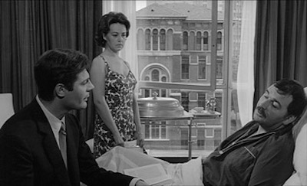
A particularly acute feminist moment comes when Lidia witnesses some young men fighting near a construction site seemingly for no reason at all. The fight summarizes patriarchy in a nutshell; macho, pointless, violent and dangerous. There is a brief moment when we think that perhaps Lidia will be hurt or even raped by the men, but she shoos them away and calls Giovanni to pick her up. The couple wanders through the nearby railway tracks where they first met and fell in love, even as the environment has taken over, and numerous wild plants have sprung up since they last visited, many years ago. Eros is still possible, even between these two. Thanatos has not won yet.
La notte makes it clear that women’s artistic talents are wasted in a society that values them only for their beauty. As if to demonstrate this, in one telling sequence, Valentina uses a tape recorder to tell a story to Giovanni. She is a far better storyteller than the author, but after she finishes her narrative, Valentina erases the tape rather than playing it back. We hear a whiny, high-pitched squeak as the recorder rewinds the tape, thus destroying her story – and making us acutely aware of the myriad untold stories of all women.
Whether or not Lidia and Giovanni’s marriage is saved at the end of La notte seems insignificant in light of the larger issues raised by the film. Antonioni offers us far bigger issues to contemplate. What have humans made of the earth? How do we love one another? What is the value of women, art and love in a world defined by men of commerce? Can we wake from our sleepwalking? These are but a few of the questions raised by La notte, a masterwork that only gets better with time, provoking a wakeful regenerative response to 21st century consumption, devaluation of Eros, and our reckless destruction of the natural world.

La notte (1961 Italy/France 122 mins)
Prod Co: Nepi Film (Rome)/ Sofitedip (Paris)/ Silva Film (Paris) Prod: Emanuele Cassuto Dir: Michelangelo Antonioni Scr: Michelangelo Antonioni, Ennio Flaiano, Tonino Guerra Phot: Gianni Di Venanzo Ed: Eraldo Da Roma,Art Dir: Piero Zuffi Mus: Giorgio Gaslini
Cast: Marcello Mastroianni, Jeanne Moreau, Monica Vitti, Bernhard Wicki, Vincenzo Corbella
Selected Filmography (as director)

- Michelangelo Eye to Eye (2004) documentary short
- Sicilia (1997) short
- Beyond the Clouds (1995)
- Noto, Mandorli, Vulcano, Stromboli, carnevale (1993) short documentary
- Kumbha Mela (1989) documentary short
- Ritorno a Lisca Bianca (1983) tv short documentary
- Identification of a Woman (1982)
- The Mystery of Oberwald (1980)
- The Passenger (1975)
- Chung Kuo – Cina (1973) documentary
- Zabriskie Point (1970)
- Blow-Up (1966)
- Red Desert (1964)
- L’Eclisse (1962)
- La Notte (1961)
- L’Avventura (1960)
- Il Grido (1957)
- Le Amiche (1955)
- I vinti (1953)
- The Lady Without Camelias (1953)
- The Funicular of Mount Faloria (1950) documentary short
- Story of a Love Affair (1950)
- Bomarzo (1949) documentary short
- Lies of Love (1949) documentary short
- Ragazze in bianco (1949) documentary
- Superstitions (1949) short documentary
- Oltre l’oblio (1948) documentary short
- Roma-Montevideo (1948) documentary short
- Seven Reeds, One Suit (1948) documentary short
- N.U. (1948) short documentary
- People of the Po Valley (1947) documentary short

50 Years of Italian Cinema
South Orange Public Library
Winter 2016-2017

Ettore Scola
1931-2016

A Special Day
1977
Ettore Scola’s “A Special Day”
Dr. Paul Baxa • September 8, 2011
Article sourced from AMU on Film: https://amufilm.wordpress.com/2011/09/08/ettore-scolas-a-special-day/

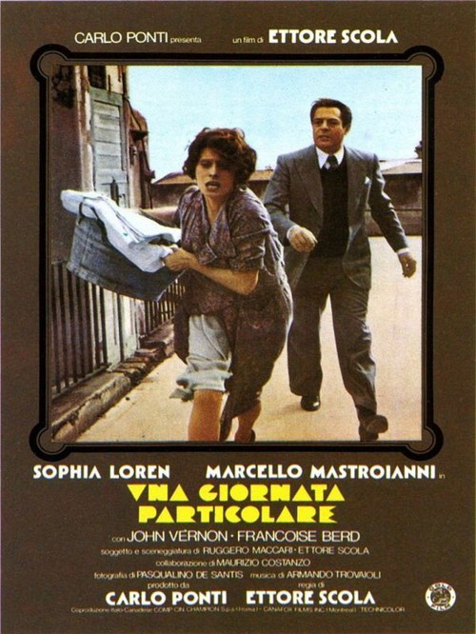
As an historian of fascist Italy, Ettore Scola’s A Special Day (Una giornata particulare) has always held a special interest for me. The film is set during one of the massive rallies which marked the visit of Adolf Hitler to Mussolini’s Rome in May 1938. The story is a private drama played out against the backdrop of a great public event that marked a high point of fascist propaganda. It was a day in which Rome was adorned with swastikas and fasces and thousands of Romans turned out to witness the parade of military and party organizations. For one day at least, it appeared as if all of Rome was united behind its Duce in greeting the visitor from Germany.
The story revolves around two characters, Antonietta and Gabriele, neighbors in the same apartment complex but strangers until they meet accidentally on the day of the rally. She is an overworked housewife, mother of six children, and married to a dedicated fascist party official who takes her for granted. Although she has a devotion to Mussolini, Antonietta elects to stay home in order to catch up on her chores. Gabriele is a former radio broadcaster who was fired by the regime when it was discovered he was a homosexual. They are worlds apart but get to know each other during the course of the day when the rest of the building’s residents are at the rally. She doesn’t know about his sexuality and assumes that he is pursuing her. He, on the other hand, is simply waiting for the inevitable; a knock on the door from the Italian police who will take him to theconfino or internal exile—the fate of those opposed to the regime or an embarrassment to it. Despite some incomprehension a close friendship and understanding develops between them. Scola’s point is to show how during the heyday of the fascist regime, when Mussolini attempted to create a totalitarian society, alternative private worlds continued to exist even amidst the triumphalism of the fascist era.
The film is remarkable for several reasons but there are three outstanding features that make it, in my opinion, a minor masterpiece. One is the characters and the actors who play them; the second is the use of archival footage and radio broadcasts; and the third is the location—an apartment complex in Rome built during the fascist era. The film stars Sofia Loren and Marcello Mastroianni, two actors who had already appeared in several films together and were indisputably Italy’s most famous film stars in the 1970s. As Peter Bondanella notes, Scola’s genius is to use both actors against type—Loren usually played a glamor girll and Mastroianni the quintessential Latin lover. In this film, Loren is a middle aged woman who wears shabby clothes and ripped stockings, while Mastroianni is a gay man. Both are brilliant and their performance alone is worth watching the film.
The second outstanding feature of the film is Scola’s skillful interweaving of archival film and radio broadcasts with the narrative. The first several minutes of the film are a collage of newsreel footage made by the LUCE Institute—the regime’s newsreel and documentary arm. Much of the story is played out against the backdrop of the radio broadcast of the events of that day which serve as a counterpoint to the drama between Antonietta and Gabriele. The radio is turned on by the building’s caretaker–an old crow who spies on the building’s residents. She appears to be the only other person in the building that day apart from the two main characters. She is the sinister face of the fascist regime and at one point gives Antonietta a warning about what happens to those who associate with men like Gabriele. It is her radio which, turned full volume, provides the other face of the regime—its triumphalism. Scola’s ability to interweave historical footage and the plot is brilliant and deserves a blog entry all its own.
Finally, there is the third—and most striking–element of the film which is the location: The Palazzo Federici. The entire film is set in this one location. Built between 1932 and 1937 the Palazzo Federici serves as an example of fascist monumentality in urban design. Designed by the modernist architect Mario De Renzi, it is composed of a series of tall residential blocks linked by elevated walkways, arches, and courtyards. The architect included a few futurist touches like the tubular, glass enclosed stairwells and elevator shafts which Scola makes much us of. The most prominent feature of the complex—and one that would figure prominently in the film—is the courtyard which makes the building a “piece of the city.” The complex was designed to express the “tumultuousness” of city life; it covered over 15,000 square meters, comprising 650 units including 100 shops and even a movie theater. Scola will use these features to make the building not only the location of the story, but also a protagonist in its own right. This is clearly demonstrated in the opening scenes of the film.
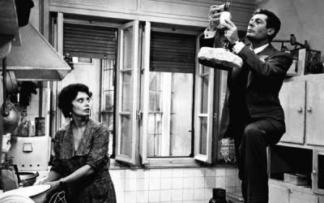
As the introductory sequence of newsreel footage ends, the film cuts to a shot of fascist banners being unfurled over the balustrade of one of the elevated walkways. Out of this comes Scola’s establishing shot, a pan of the residential towers which surround the courtyard. This shot is done in such a way that it demonstrates the sheer verticality of what was considering a small skyscraper in the context of 1930s Rome. It is clearly early morning and all the windows are dark. Gradually, the lights turn on in each unit. Scola’s camera pans along one floor of the building and we see through the windows as families begin to rise and prepare for the rally. It is a shot reminiscent of Hitchcock’s Rear Window. Eventually, the camera stops at one window and moves into the unit where we see Antonietta ironing fascist uniforms and preparing coffee.
In a sequence that Scola will use often throughout the film, we follow Antonietta through her labyrinthine apartment as she wakes up her six children and husband, Emanuele, played by Canadian actor Richard Vernon. The scene is chaotic as the family scrambles to get into their uniforms. It begins badly for Antonietta who chastises her daughter for putting on lipstick, finds a pornographic magazine in her son’s bed, and rows with her husband who gave that picture to his son. Scola’s tracking shots clearly bring out the claustrophobic atmosphere of the apartment which is too small for the large family. It is a maze of rooms and doors which seem to have no discernable floor plan. Everything seems to lead to the cramped and untidy kitchen. The apartment is disorienting, a reflection of the similarly mazelike building of which it is a part.
The scene then shifts to another striking sequence in Scola’s film—the emptying of the building as hundreds of men, women, and children spill out into the courtyard in their fascist uniforms on their way to the rally. It is a dynamic scene which makes effective use of De Renzi’s architecture especially the tubular, transparent stairwells and the walkways through the courtyard. The impression is that of a giant ant colony. As the crowds make their way to the street they are cheered on by the caretaker who is largely ignored.
Scola makes much of the two apartments which reveal the different worlds inhabited by Gabriele and Antonietta. When Antonietta’s mynah bird escapes from its cage and lands on Gabriele’s window ledge we enter his apartment. In contrast to Antonietta’s cramped living quarters, filled with family heirlooms and old furniture, Gabriele’s apartment is orderly and tidy with modern furniture and works of modern art on the walls. Scola will make much of one painting which hangs near the door and draws a puzzled look from Antonietta. Later on, Gabriele’s last act before being led out by the police to exile is to carefully wrap the painting and put it under his arm. On the floor of the apartment are laid out the footsteps for the rumba dance which Gabriele demonstrates to a clearly embarrassed Antonietta who becomes conscious of her frumpy dress and broken slippers.
In contrasting the apartments Scola is making a commentary on the broken lives left behind by fascist propaganda. Antonietta, as it turns out, is in a loveless marriage to a man who “knows only how to give orders.” She surrounds herself with the artifacts of domesticity—faded family pictures, diplomas, and hand me downs. The apartment also has its share of kitsch—souvenir albums of Mussolini and a portrait of the Duce made of buttons as well as vulgar fascist publications and cartoons. Gabriele, on the other hand, surrounds himself with culture—modern paintings, records, and stacks of books one of which, Dumas’ Three Muskateers, he gives to Antonietta who is barely literate. The impression though is of a sterile environment which provides little consolation.
Throughout the film, Scola will make use of the building’s features. Stairways, corridors, doors and windows are utilized abundantly. In one shot we see Gabriele making himself an omelet through one door, while Antonietta watches him through another. Most prominent of all is the courtyard which is almost always present through the large windows of the apartments. It is here that Scola reveals the truly fascist nature of the De Renzi building—it is designed for surveillance. In modernist architecture windows are used to represent lightness and transparency but here they are a means of obliterating the private world. As Gabriele and Antonietta become closer, they take steps to avoid this surveillance (especially from the caretaker who makes it clear that she has her eye on the pair). Rather than walk down the stairwell and through the courtyard, they begin to use the roof and the boiler room (where Antonietta bangs her head on a pipe). The courtyard clearly belongs to the regime—those who are outsiders are left to find their way through the alleys and tunnels of the building’s interior.
It is here that Scola’s brilliant use of the building is fully realized. The director is able to at once demonstrate both the fascist and anti-fascist potential of the Palazzo Federici and of modernist architecture in general—a style that can be both liberating and repressive at the same time. When the fascists return home, they are once again greeted by the caretaker, and once again they largely ignore her empty, bombastic exhortations. Antonietta, who has clearly been changed by her encounter with Gabriele now sees the courtyard in a different light. As night descends on the city, she is the only one who notices a lonely figure being escorted by two policemen through the courtyard and out the arched gate of the complex into exile.

Selected Filmography (as director)

- Let's Talk About Women (1964)
- Thrilling (1965)
- Hard Time for Princes (1965)
- The Devil in Love (1966)
- Will Our Heroes Be Able to Find Their Friend Who Has Mysteriously Disappeared in Africa? (1968)
- Police Chief Pepe (1969)
- The Pizza Triangle (1970)
- My Name Is Rocco Papaleo (1971)
- The Most Wonderful Evening of My Life (1972)
- Trevico-Turin: Voyage in Fiatnam (1973)
- Festival Unità (1973) – documentary
- We All Loved Each Other So Much (1974)
- Goodnight, Ladies and Gentlemen (1976)
- Down and Dirty (1976)
- A Special Day (1977)
- Viva l'Italia! (1977)
- La terrazza (1980)
- Passion of Love (1981)
- That Night in Varennes (1982)
- Vorrei che volo (1982) – documentary
- Le Bal (1983)
- Macaroni (1985)
- Imago urbis (1987) – documentary
- The Family (1987)
- Splendor (1988)
- What Time Is It? (1989)
- Captain Fracassa's Journey (1990)
- Mario, Maria and Mario (1993)
- Romanzo di un giovane povero (1995)
- The Dinner (1998)
- Unfair Competition (2001)
- Un altro mondo è possibile (2001) – documentary
- Lettere dalla Palestina (2002) – documentary
- Gente di Roma (2003)
- How Strange to Be Named Federico (2013) - documentary

50 Years of Italian Cinema
South Orange Public Library
Winter 2016-2017

Giuseppe Tornatore
b.1956

Cinema Paradiso
1988
Cinema Paradiso (1989)
Felicia Feaster • August 27, 1947
Article sourced from Turner Classic Movies: http://www.tcm.com/tcmdb/title/70942/Cinema-Paradiso/articles.html

A famous Rome film director, Salvatore (Jacques Perrin), learns of the death of an elderly film projectionist, Alfredo (Philippe Noiret), and flashes back to his formative years growing up in a small postwar Sicilian village under Alfredo's tutelage.
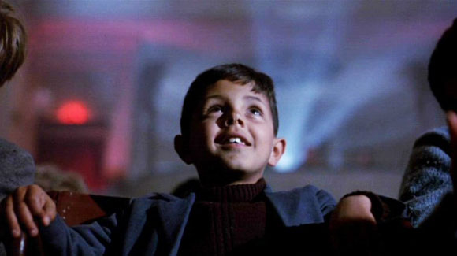
In the village of Giancaldo, Salvatore's childhood revolved around the local cinema, the Cinema Paradiso, and the elderly projectionist Alfredo (Philippe Noiret) who schooled the young Salvatore (Salvatore Cascio) on the magic of cinema and functioned as a father figure to the impressionable boy whose mother (Antonella Attili) pines for the husband she lost in World War II.
At the Cinema Paradiso, Alfredo and Salvatore (a.k.a. Toto) bond over their love of cinema, one which is severely altered by the local priest Father Adelfio (Leopoldo Trieste) who censors any show of passion on the screen by ringing a little bell. Over the years, Alfredo saves the precious bits of celluloid containing those excised screen kisses.
Despite the priest's censorial intervention, the Paradiso is the town's favorite meeting ground, a place where the populace can escape postwar misery, and a kind of church for Giancaldo's citizenry. At the Cinema Paradiso, the townsfolk go for romance, to cry, to nurse their babies, smoke and laugh in director Giuseppe Tornatore's paean to moviegoing's fading, communal nature.
As Salvatore grows into a teenager (Marco Leonardi), other pursuits beyond John Wayne movies begin to catch his eye, including Elena (Agnese Nano), the beautiful daughter of the town's banker. When the Cinema Paradiso burns down and Alfredo is blinded, Salvatore eventually becomes the projectionist at the town's new theater, welcoming in a new era of cinema in the erotic figure of Brigitte Bardot. But military service separates Elena and Salvatore, who is eventually prodded by Alfredo to leave his small town behind for the promise and potential of Rome.
A film about "what one might call (in a soggy moment) the magic of movies" (in the words of New York Times film critic Vincent Canby), Giuseppe Tornatore's Cinema Paradiso (1989) has been called a love letter to the movies greeted with reverent enthusiasm by some critics, and seen as saccharine and convention laden by others. In the course of the film, the Cinema Paradiso screens an impressive array of world cinema and Tornatore's film features clips from such renowned classics as Fritz Lang's Fury (1936), Jean Renoir's The Lower Depths (1936), Luchino Visconti's La Terra Trema (1948) and John Ford's Stagecoach (1939).
Despite some critical disagreement about the film's charms, the Italian-French co-production of Cinema Paradiso received an Oscar in 1990 for Best Foreign Language Film and the Grand Jury Prize at the 1989 Cannes Film Festival.
To find an actor to play the young Salvatore, Tornatore photographed some 300 Sicilian boys for the part. The film was shot in Tornatore's hometown of Bagheria, Sicily and was drawn from the director's own life and times. The film was intended as a kind of obituary of traditional movie theaters like the Paradiso, and of traditional moviegoing, though the film's international success proved communal cinema-love was not dead. Before becoming a film director, Tornatore was a still photographer, then a television documentary maker who made his film debut with The Professor (1985).
In 2002 a director's cut of the film appeared, which restored 51 minutes to the film, raising Cinema Paradiso's running time to almost 3 hours. Much of the director's cut included a grown-up continuation of the teenage romance between Salvatore and Elena. For the most part, critics saw it as an inferior version.
Director: Giuseppe Tornatore
Producer: Franco Cristaldi, Giovanna Romagnoli
Screenplay: Giuseppe Tornatore and Vanna Paoli
Cinematography: Blasco Giurato
Production Design: Andrea Crisanti
Music: Andrea and Ennio Morricone
Cast: Philippe Noiret (Alfredo), Jacques Perrin (adult Salvatore), Antonella Attili (Young Maria), Enzo Cannavale (Spaccafico), Isa Danieli (Anna), Leo Gullotta (Usher), Marco Leonardi (adolescent Salvatore), Pupella Maggio (Old Maria), Agnese Nano (adolescent Elena), Leopoldo Trieste (Father Adelfio), Salvatore Cascio (Child Salvatore).
C-123m. Letterboxed.

Selected Filmography (as director)

- The Correspondence (2016)
- The Best Offer (2013)
- Baarìa (2009)
- The Unknown Woman (2006)
- Malèna (2000)
- The Legend of 1900 (1998)
- Ritratti d’autore: seconda serie (1996) documentary
- Lo schermo a tre punte (1995) documentary
- The Star Maker (1995)
- A Pure Formality (1994)
- Everybody’s Fine (1990)
- Cinema Paradiso (1988)
- The Professor (1986)

Michelangelo Antonioni, “My Film,” L’humanite February 26, 1961, trans. Nicholas Elliott, archived on The Criterion Collection Website, November 4, 2013, <http://www.criterion.com/current/posts/2937-my-film>.
Pauline Kael, “The Come-Dressed-As-the-Sick-Soul-of-Europe Parties: La Notte, Last Year at Marienbad, La Dolce Vita,” in I Lost it at the Movies: Film Writings, 1954-1965 (Boston: Little, Brown; 1965), pp. 161-175.
Christopher Sharrett, “L’eclisse,” Senses of Cinema 62 (March 2012), <http://sensesofcinema.com/2012/cteq/leclisse/>.
Christopher Sharrett, “Red Desert,” Cineaste 36.1 (2010), <http://www.cineaste.com/articles/emred-desertem-web-exclusive>.
Hermann Broch, The Sleepwalkers (First publication London: Martin Secker, 1932, trans. Willa and Edwin Muir (New York: Vintage, 1996).
Peter Bondanella, Italian Cinema: From Neorealism to the Present (New York: Continuum, 2000), 367-368.
Alfredo Carlomagno and Giuseppe Saponaro, Mario De Renzi, 1897-1967(Rome: Edizioni Clear, 1999), 29.
Ibid.

